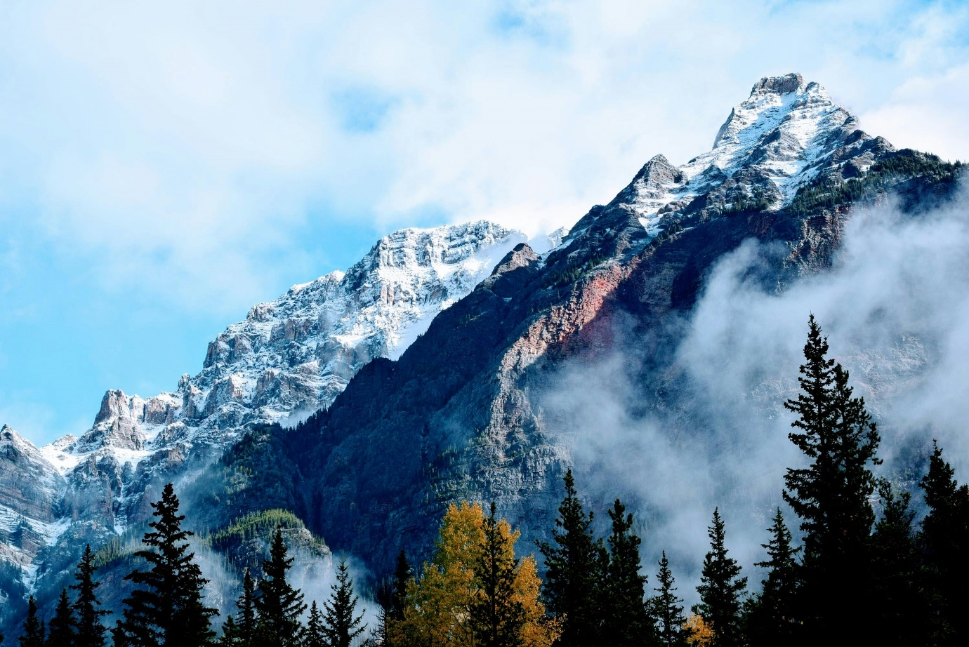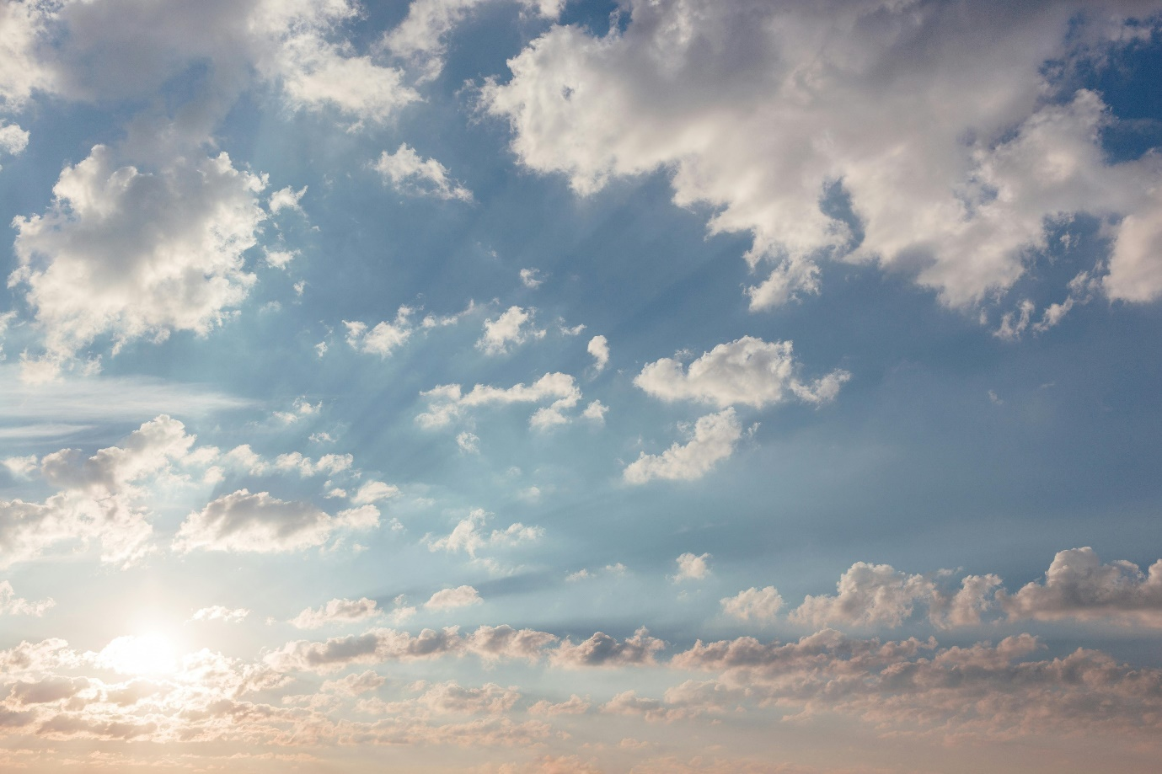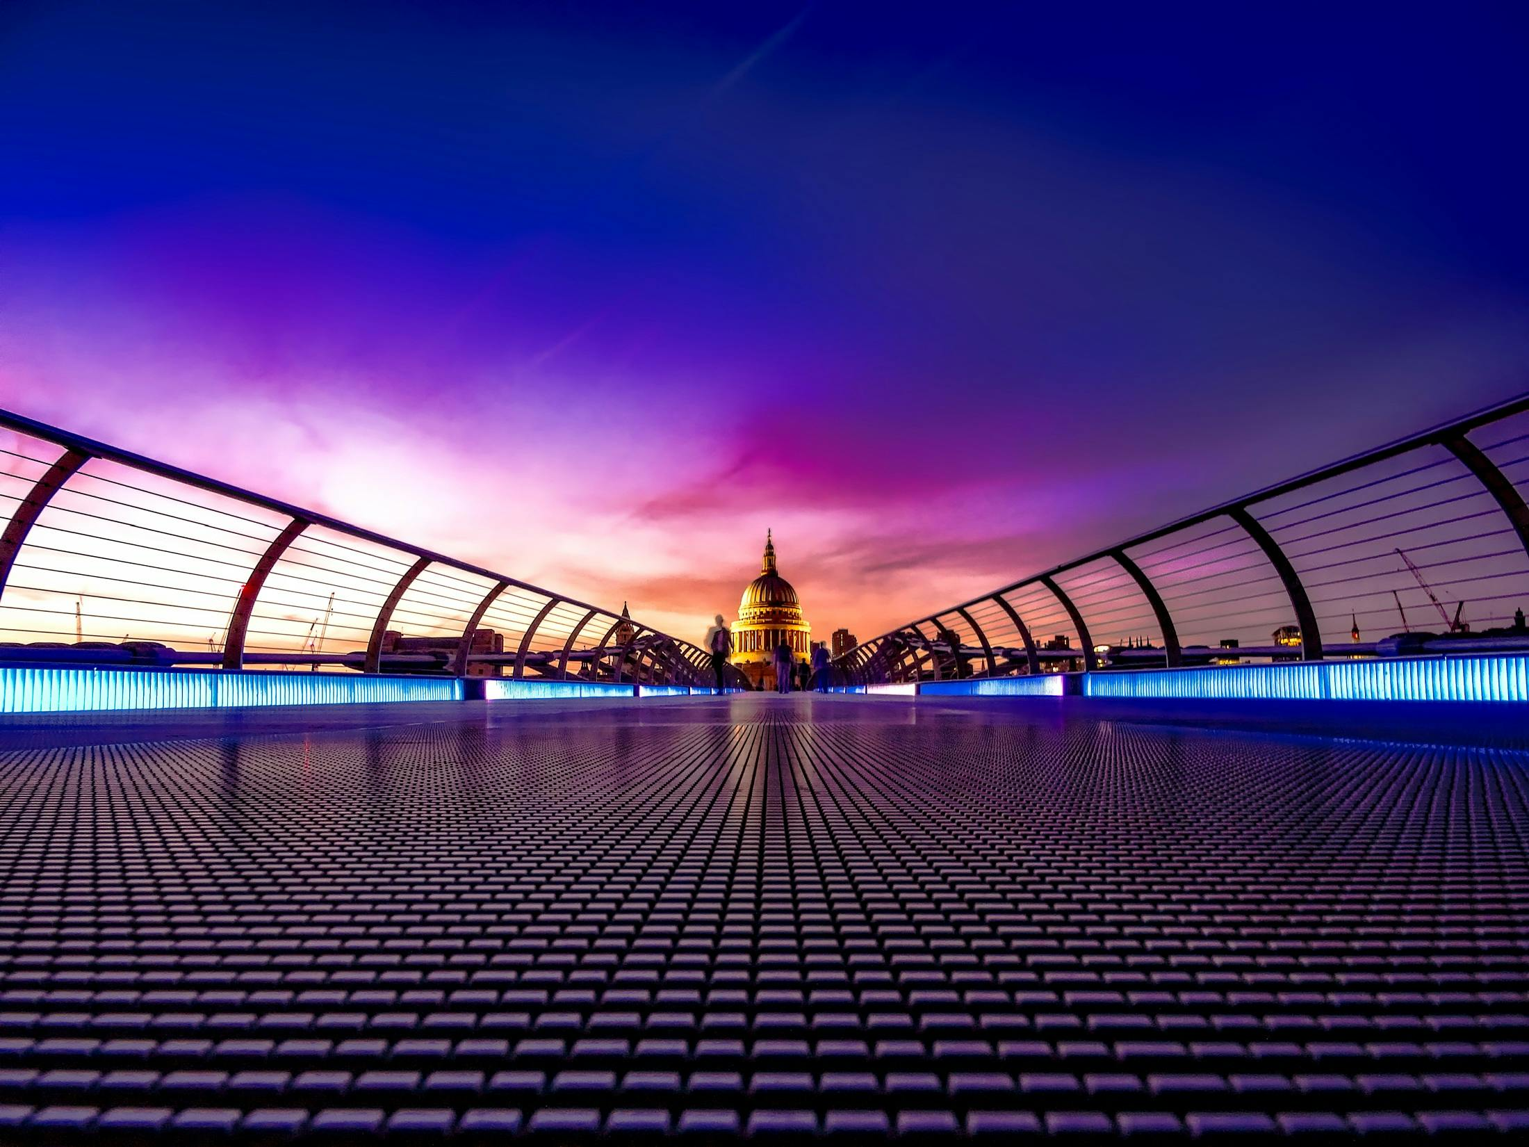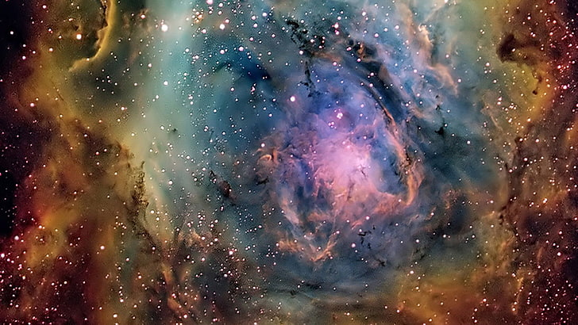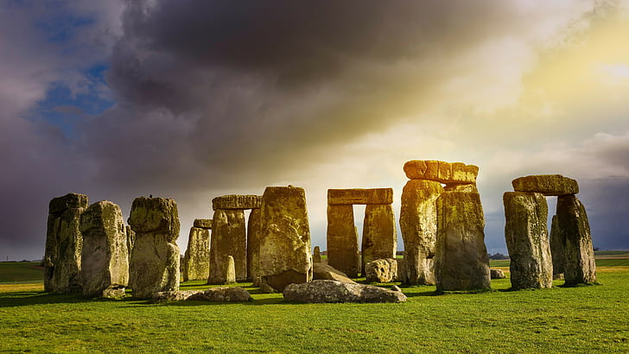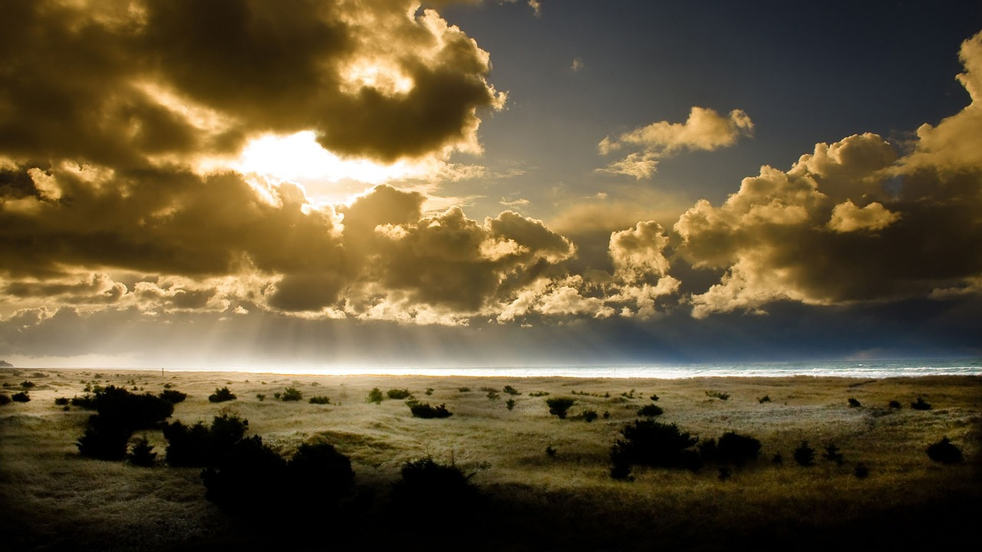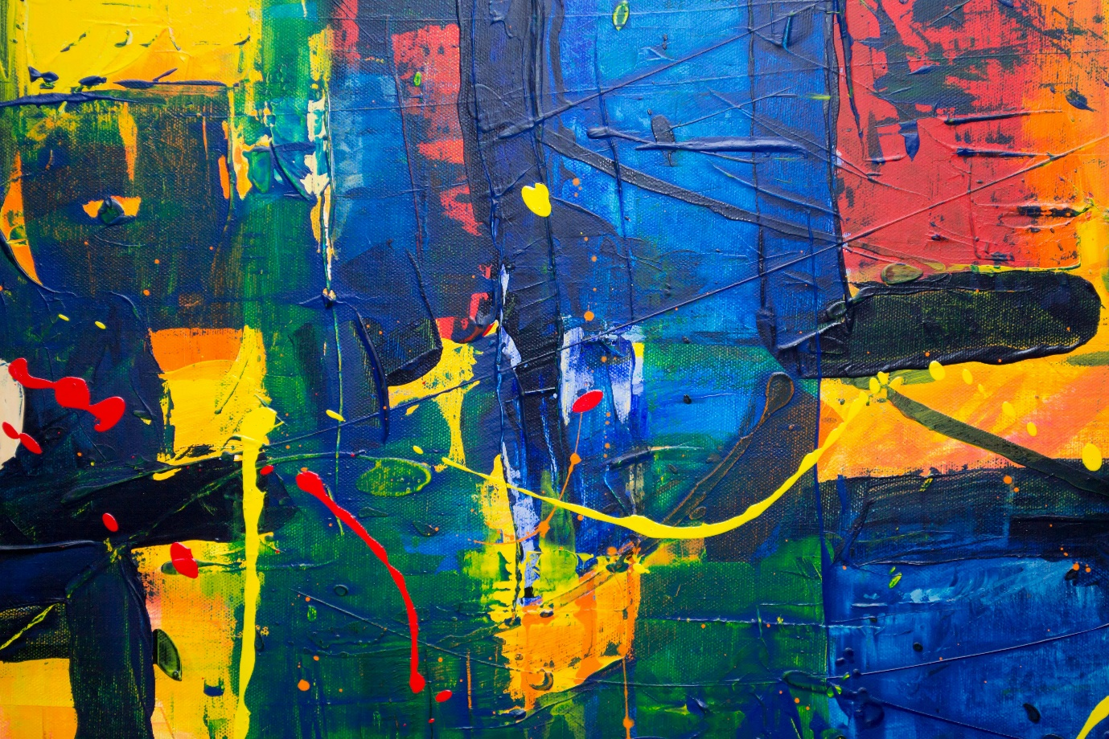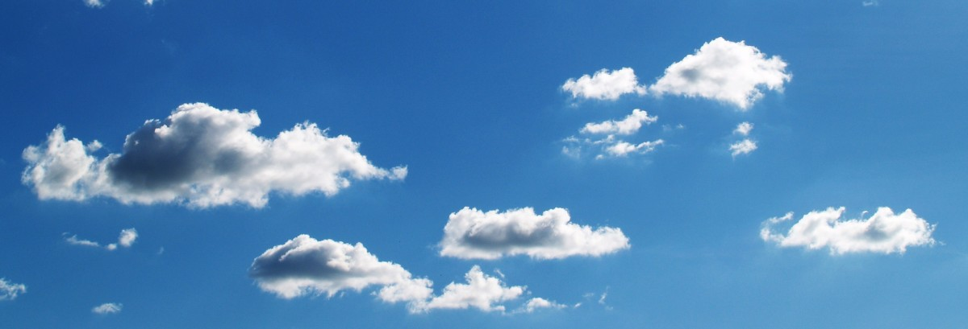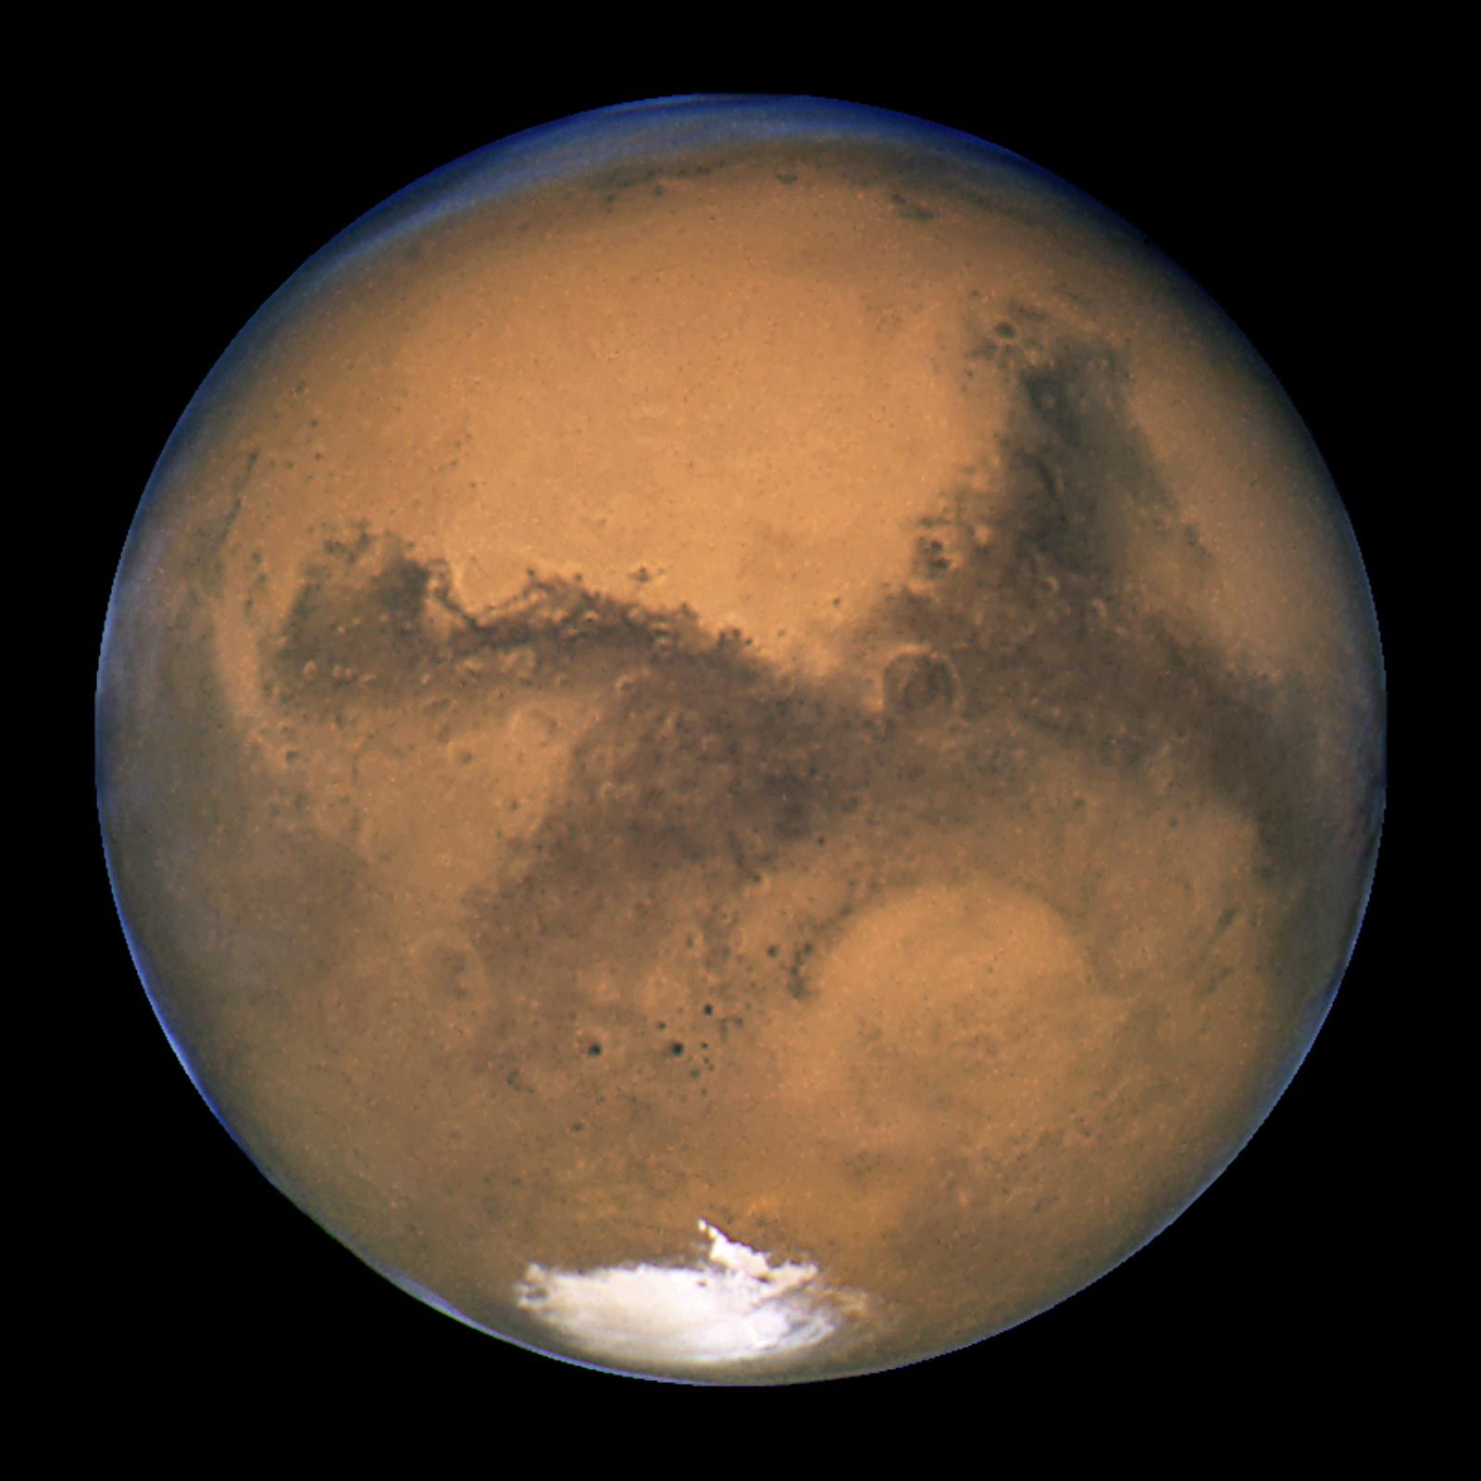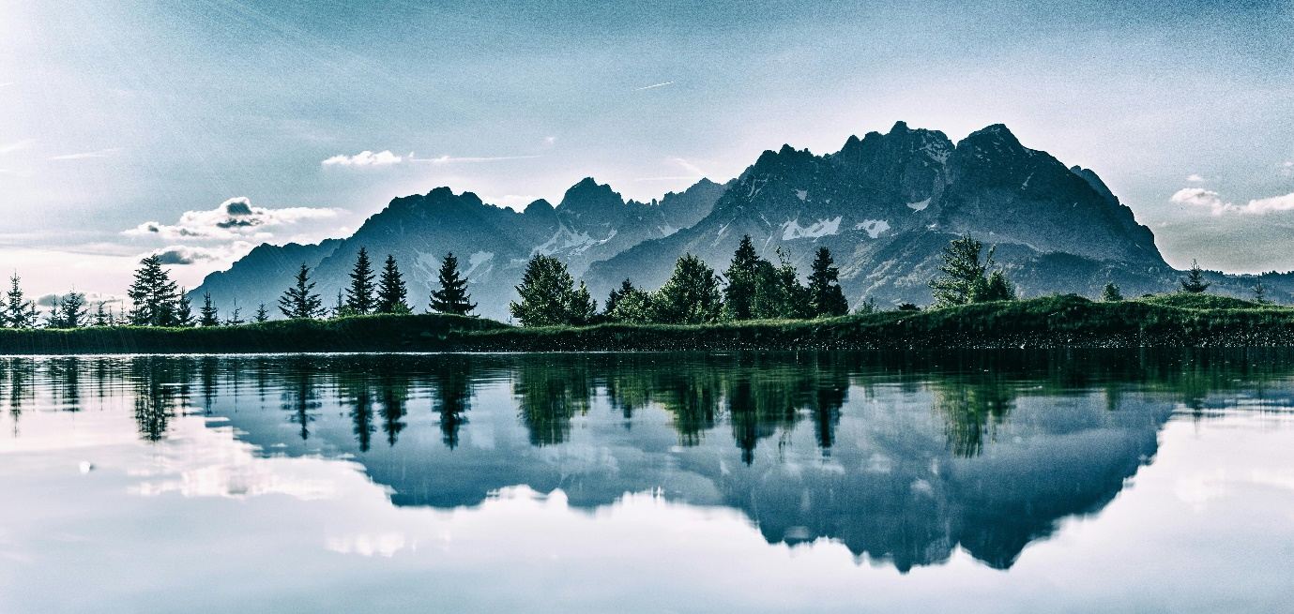

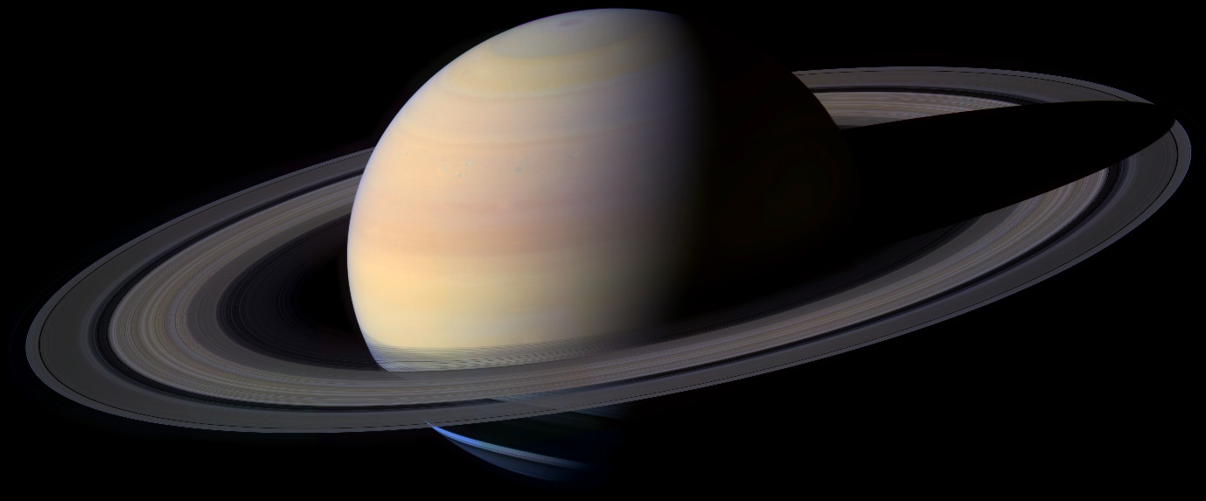

[This Photo](http://commons.wikimedia.org/wiki/File:Saturn_-_High_Resolution,_2004.jpg) by Unknown Author is licensed under [CC BY-SA](https://creativecommons.org/licenses/by-sa/3.0/)

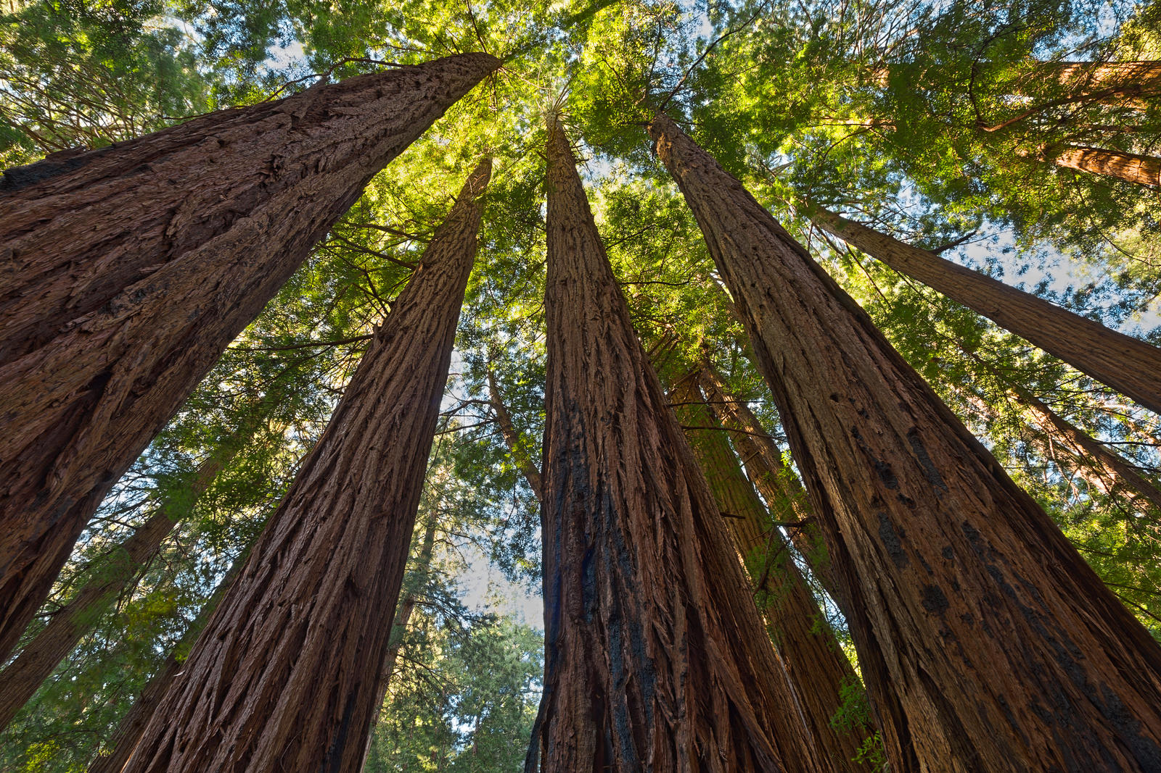

[This Photo](https://somadjinn.deviantart.com/art/Muir-Woods-Foliage-II-Free-High-Res-HDR-Stock-429407899) by Unknown Author is licensed under [CC BY](https://creativecommons.org/licenses/by/3.0/)

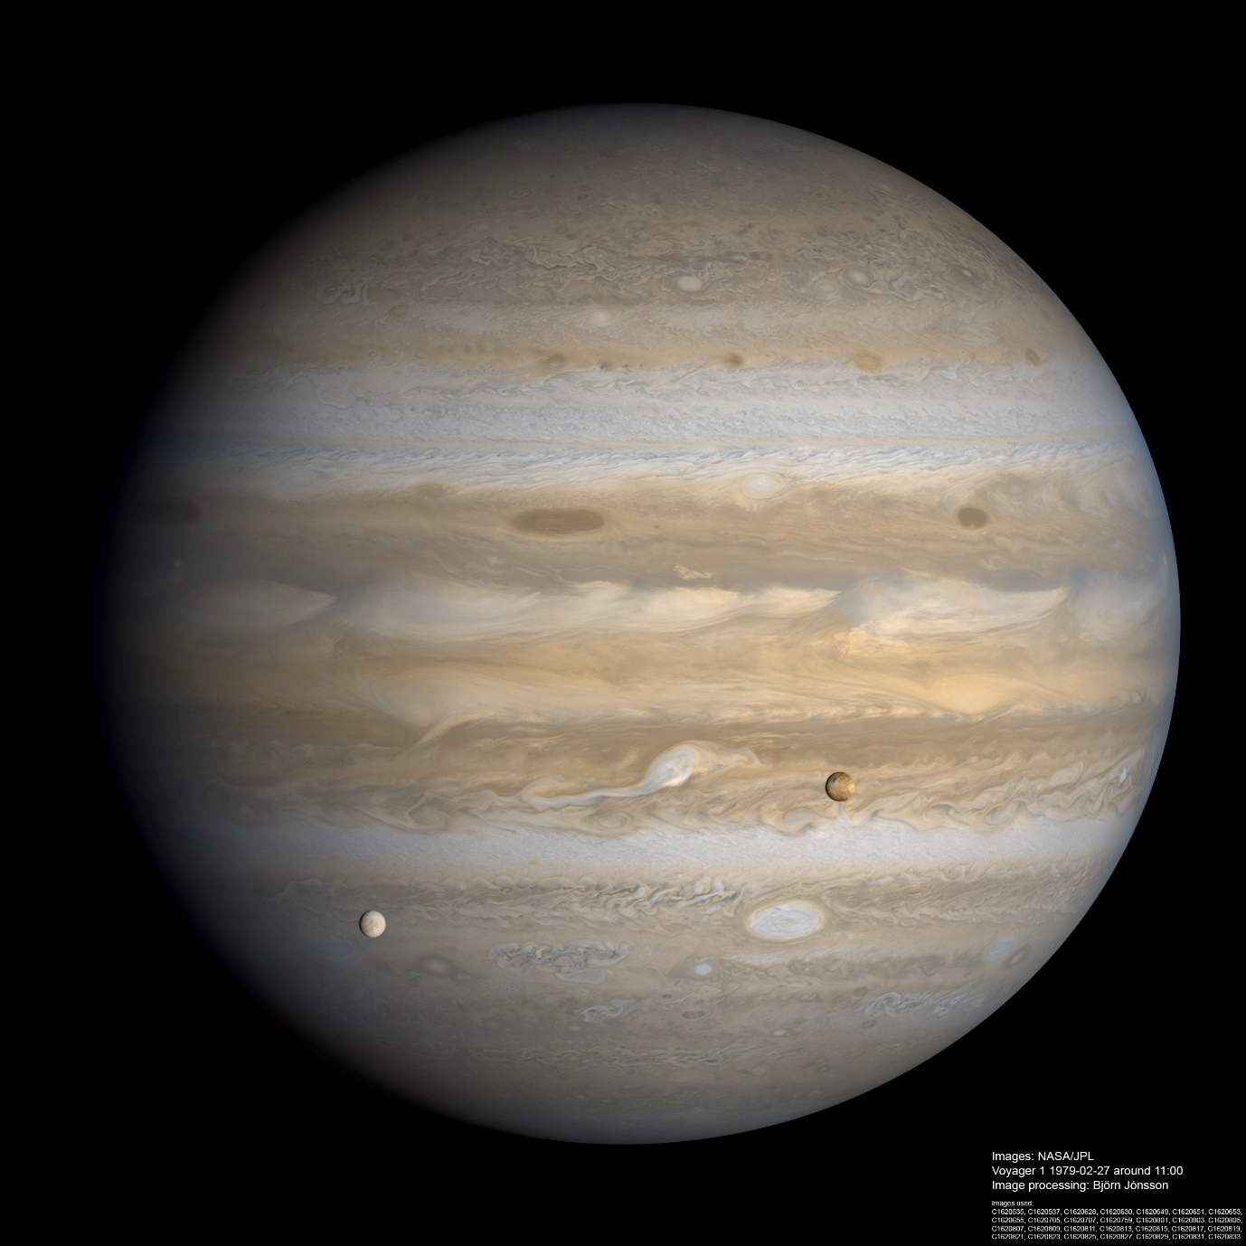

[This Photo](http://www.planetary.org/multimedia/space-images/jupiter/high-resolution-voyager-1.html) by Unknown Author is licensed under [CC BY-SA-NC](https://creativecommons.org/licenses/by-nc-sa/3.0/)



[This Photo](https://www.pngall.com/powerpoint-frame-png/) by Unknown Author is licensed under [CC BY-NC](https://creativecommons.org/licenses/by-nc/3.0/)

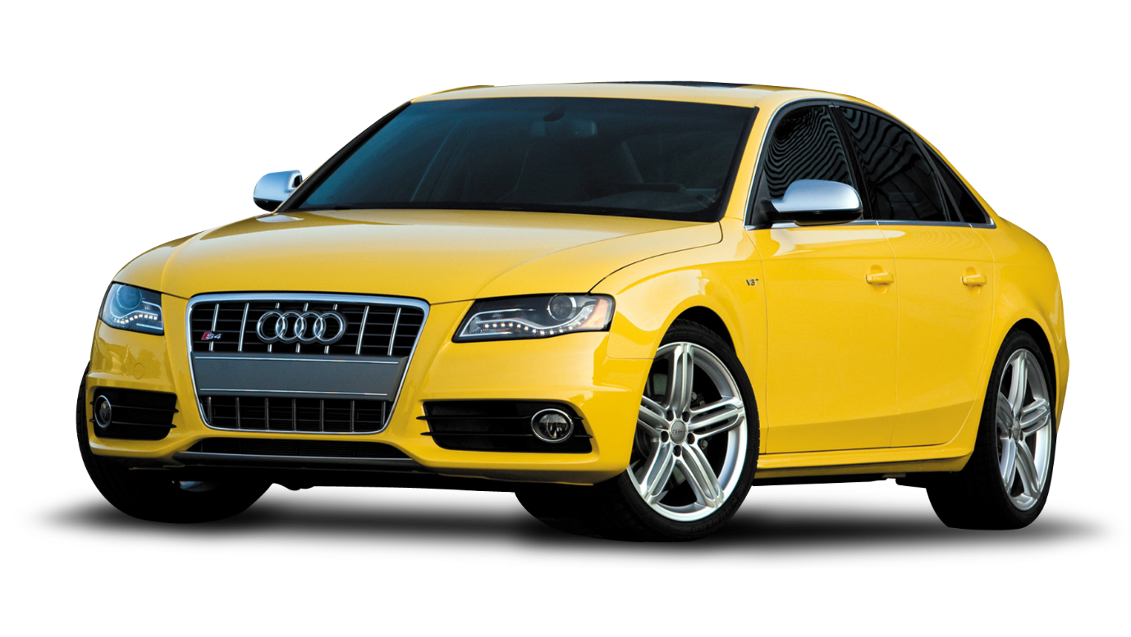

[This Photo](https://freepngimg.com/png/11321-car-high-quality-png) by Unknown Author is licensed under [CC BY-NC](https://creativecommons.org/licenses/by-nc/3.0/)

